Faculty of Engineering, Science & Technology
IQRA UNIVERSITY


PROGRAMMING FUNDAMENTAL (LAB)

(Tuesday 11:45-13:05 C-LAB-03)
Project Report
[Fall-2024]

Name: | Kashif Raza, Ameen Dahani, Ghulam Ullah
Registration no: | 17221, 17115, 17117
Group No:
Project Name: | Inventory Management System
Instructor: | Hammad Ahmad

Acknowledgment

I would like to extend my gratitude to Sir Hammad for invaluable guidance and dedication in teaching us the programming fundamentals using C++. Your engaging teaching style and ability to simplify complex concepts have been instrumental in building our foundation in programming.

Thank you, Sir Hammad, for your patience, knowledge, and commitment to our learning journey. Your efforts have truly made a lasting impact on our understanding and confidence in programming.

Abstract

This program is a C++-based Inventory Management System designed to streamline the handling of inventory data, including item names, quantities, and prices. It employs a menu-driven interface, allowing users to perform essential operations such as adding new items, displaying the inventory, searching for specific items, updating quantities, and deleting items. Using the vector container ensures dynamic storage, making it suitable for managing inventories of varying sizes. The program emphasizes simplicity, functionality, and modularity, serving as a learning resource and practical application for managing data with C++.
Table OF CONTENTS
Chapters | Title | Key Topics | Pages
Chapter 1 | Objectives
  Purpose of the system, key goals, and expected outcomes.
Chapter 2 | Introduction
  Overview of the Inventory Management System, its purpose, target audience, and the importance of efficient inventory management.
Chapter 3 | Background
  Detailed explanation of inventory management systems, related technologies, challenges in inventory control, and how this system addresses them.
Chapter 4 | Prototype
  Design and implementation of the system, including data structures (e.g., Product, Inventory), core functionalities (add, remove, update), and file handling.
Chapter 5 | Conclusion
  Summary of the system’s features, its limitations, and future improvements or potential extensions.

1.Objectives:
- To develop a simple and interactive Inventory Management System using C++.
- To demonstrate the use of structs, vectors, and functions in organizing and managing inventory data.
- To provide a menu-driven interface for users to perform common inventory operations like adding, displaying, searching, updating, and deleting items.
- To enhance the understanding of iterative control structures (do-while loop) and conditional decision-making (switch statement).

2.Introduction:

The Inventory Management System is a C++ program designed to simulate a basic inventory management application. It allows users to keep track of items, including their names, quantities, and prices. By leveraging the vector container, the program dynamically manages the inventory without a fixed size. The system is modularized using functions for better readability, maintainability, and scalability. This program is an excellent demonstration of object-oriented concepts like encapsulation and practical usage of data structures in real-world applications.

3.Background:
Inventory management is a fundamental aspect of business operations, ensuring that stock levels are monitored and maintained efficiently. Traditional methods often involve manual records, which can be prone to errors and inefficiencies. In this context, computer-based solutions, such as this Inventory Management System, offer a reliable and automated alternative. The program utilizes essential C++ features like structs for data organization, vectors for dynamic storage, and functions for modularity. By integrating these features, the program provides a simplified yet effective tool for managing inventory, making it a valuable example for learning fundamental programming concepts.

4.Prototype:
The prototype of the Inventory Management System consists of several key components that collectively support product management and data persistence. The system allows users to interact with the inventory through a simple command-line interface, which provides a set of operations like adding, removing, updating, and viewing products.
Screenshots:
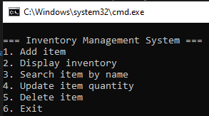
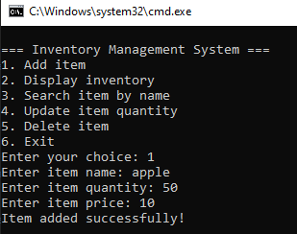
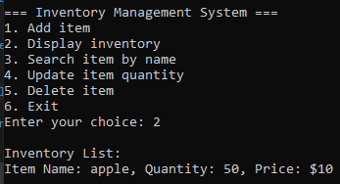
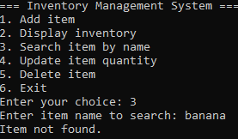
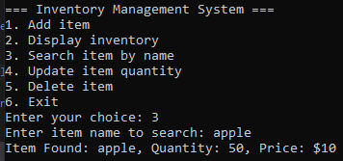
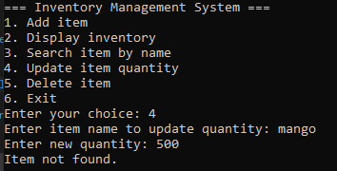
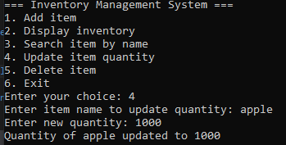
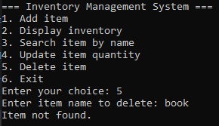
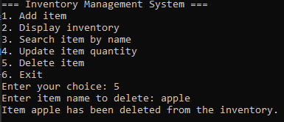

5.Conclusion:
This Inventory Management System effectively demonstrates the use of C++ programming constructs to solve a real-world problem. By integrating arrays, structures, pointers, file handling, functions, and loops, the program showcases the power and versatility of C++. It provides a solid foundation for building more advanced inventory systems and helps users understand key programming concepts in a practical setting.

